# **Section 3 Quiz - OpenShift Introduction, Architecture and Management**

1. OpenShift is Red Hat's ________ offering
   1. Infrastructure-As-A-Service (IaaS)
   2. Platform-As-A-Service (PaaS)
   3. Software-As-A-Service (SaaS)
2. Which among the below is the original upstream project from which all other models are derived?
   1. OpenShift Online
   2. OpenShift Enterprise
   3. OpenShift Cloud
   4. OpenShift Beginning
   5. OpenShift Origin
3. Which among the below is a managed private offering of OpenShift on cloud platforms such as AWS/Google Cloud etc?
   1. OpenShift Online
   2. OpenShift Origin
   3. OpenShift Cloud
   4. OpenShift Dedicated
   5. OpenShift Enterprise
4. Which among the below is Red Hat's on premise private PaaS offering of OpenShift?
   1. OpenShift Online
   2. OpenShift Dedicated
   3. OpenShift Enterprise
   4. OpenShift PaaS
5. OpenShift is built on which of the below technologies?
   1. Docker
   2. Kubernetes
   3. Docker and Kubernetes
6. The Master Systems in OpenShift host application in the form of Docker Containers.
   1. True
   2. False
7. The OpenShift API server is hosted on
   1. Master Systems
   2. Nodes
   3. Minions
8. The key-value store used by OpenShift to store and transit data through-out the cluster is
   1. Redis
   2. etcd
   3. Web Console
   4. SQL
9. What are the different ways of managing OpenShift?
   1. Web Console
   2. CLI
   3. REST API
   4. All of the Above
10. Which of the below management interfaces is best suited to integrate OpenShift with third party applications?
    1. Web Console
    2. CLI
    3. REST API
11. Which is the utility used to interact with OpenShift via command line?
    1. Powershell
    2. OpenShift Client tool, also known as OC tool
    3. Shell Script
12. When I try to run the below Rest API to list projects, I get the below response. Looks like there is an error. What could be the problem and how do I resolve it?

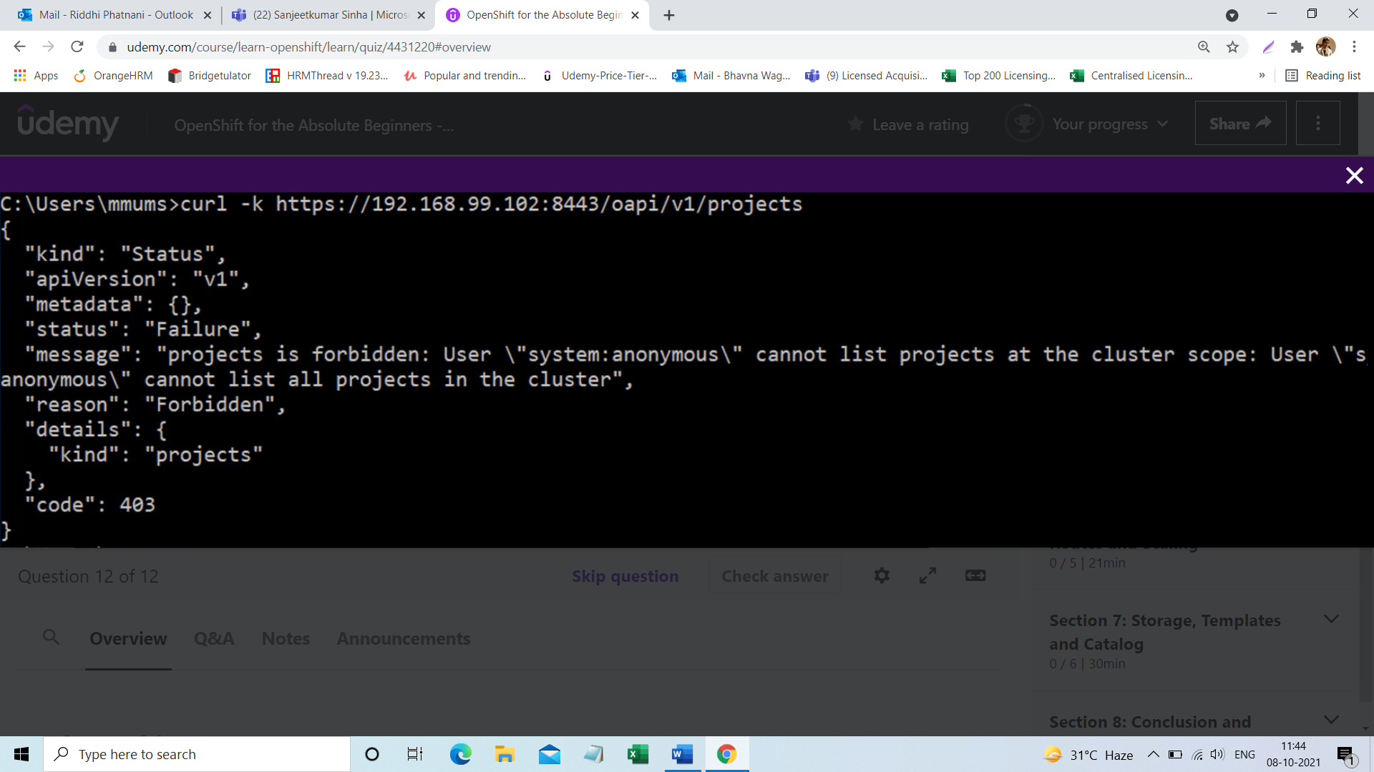

* 1. The URL is pointing to the wrong IP address, try using another IP address.
  2. CURL is not working. Try another REST tool.
  3. Authentication issue. Send an Authorization header with a token.
  4. Openshift cluster is down. Try restarting the cluster.

# **Answers**

1. b
2. e
3. d
4. c
5. c
6. b
7. a
8. b
9. d
10. c
11. b
12. c

# **Section 4 Quiz - Projects and Users**

1. Which among the below is a regular user?
   1. developer
   2. system:admin
   3. system:developer
2. For a Minishift setup, what is the default Identity Provider set to?
   1. Active Directory
   2. SSO
   3. Allow All
   4. Deny All

# **Answers**

1. a
2. c